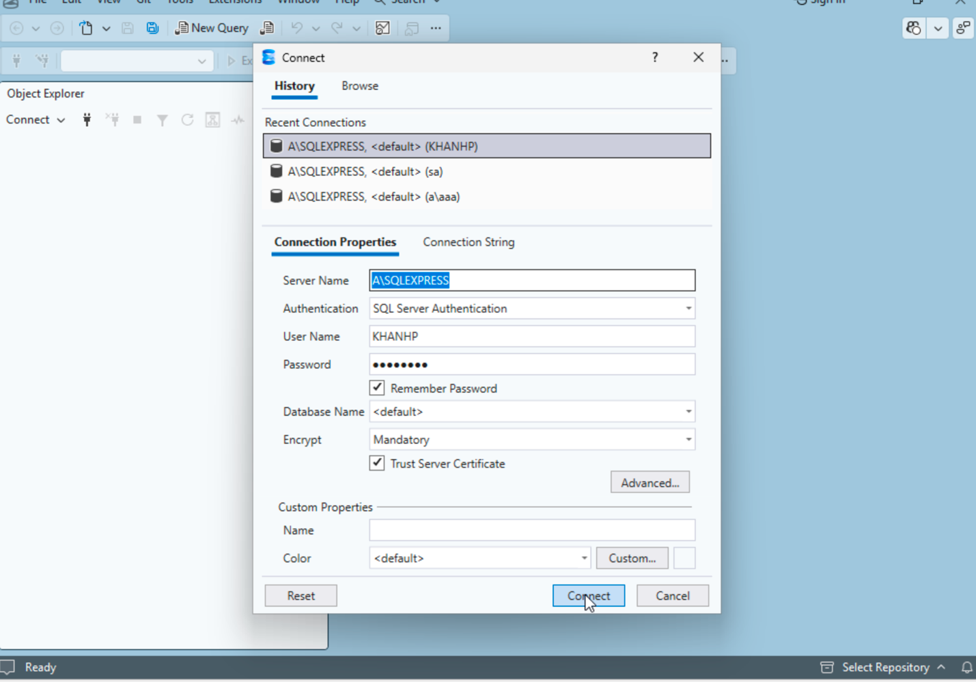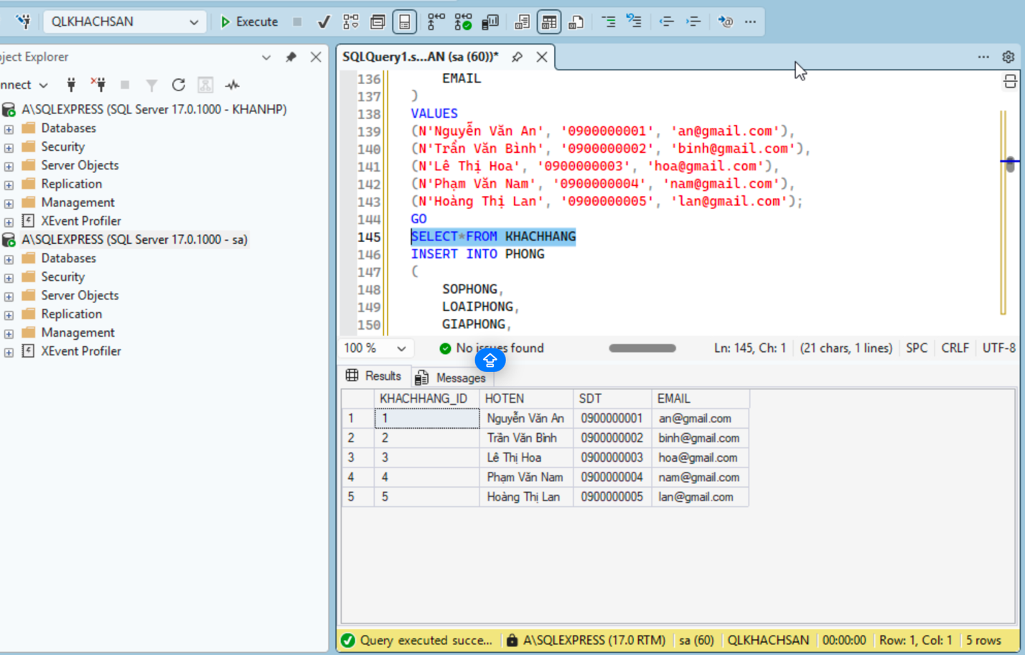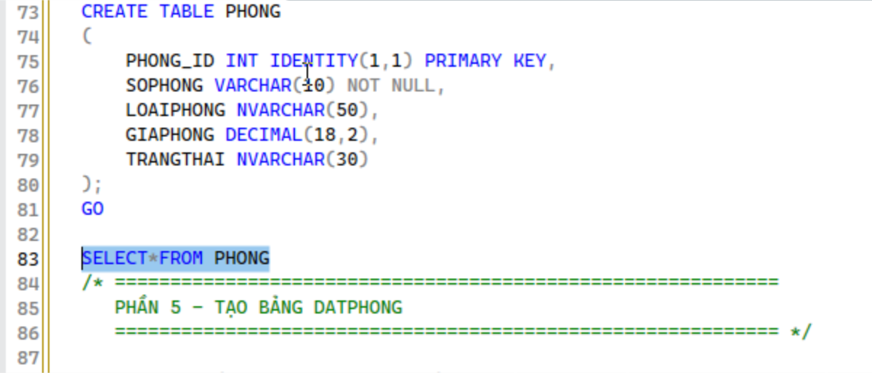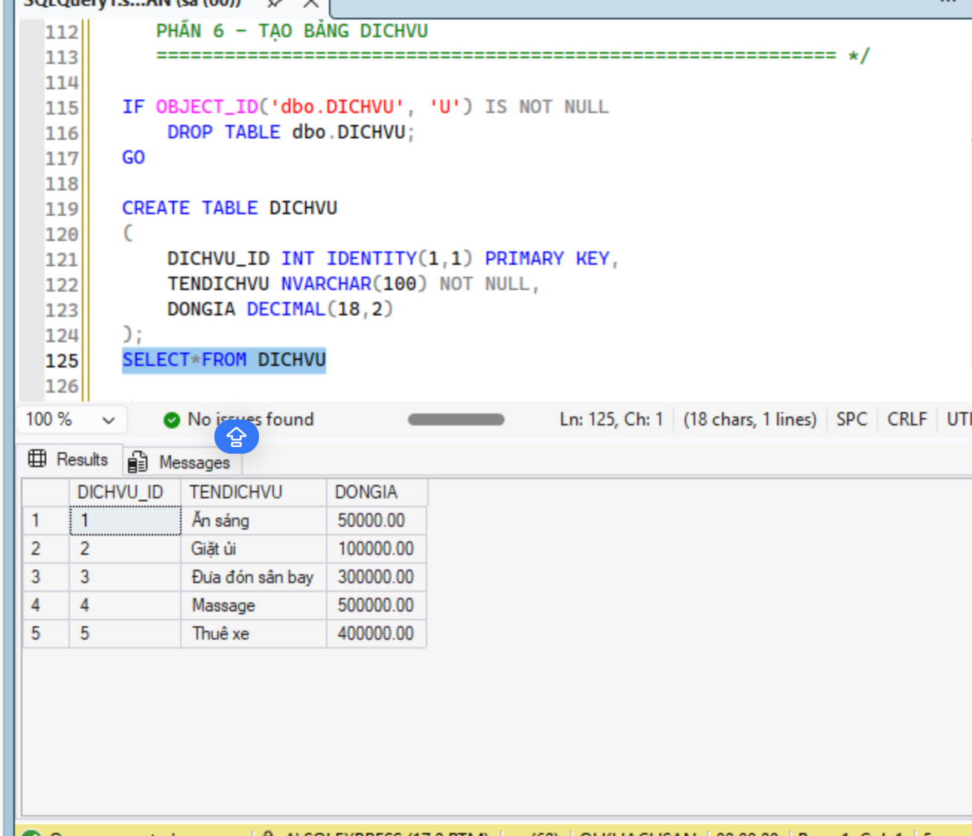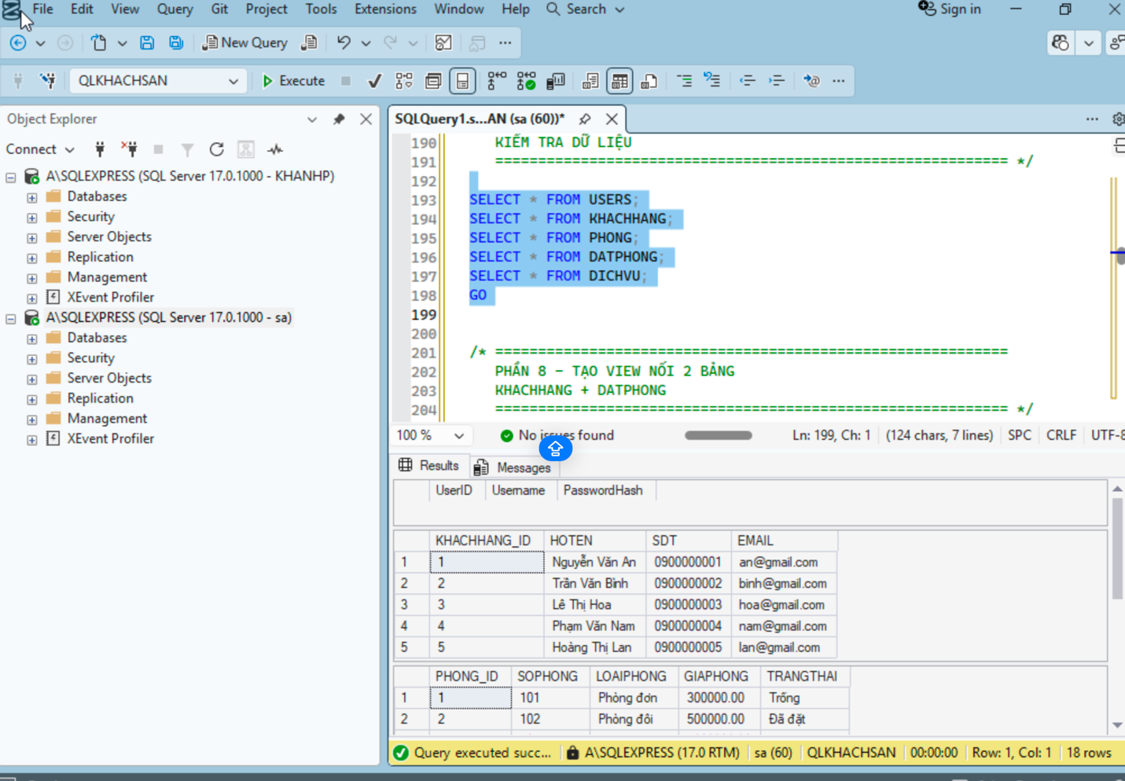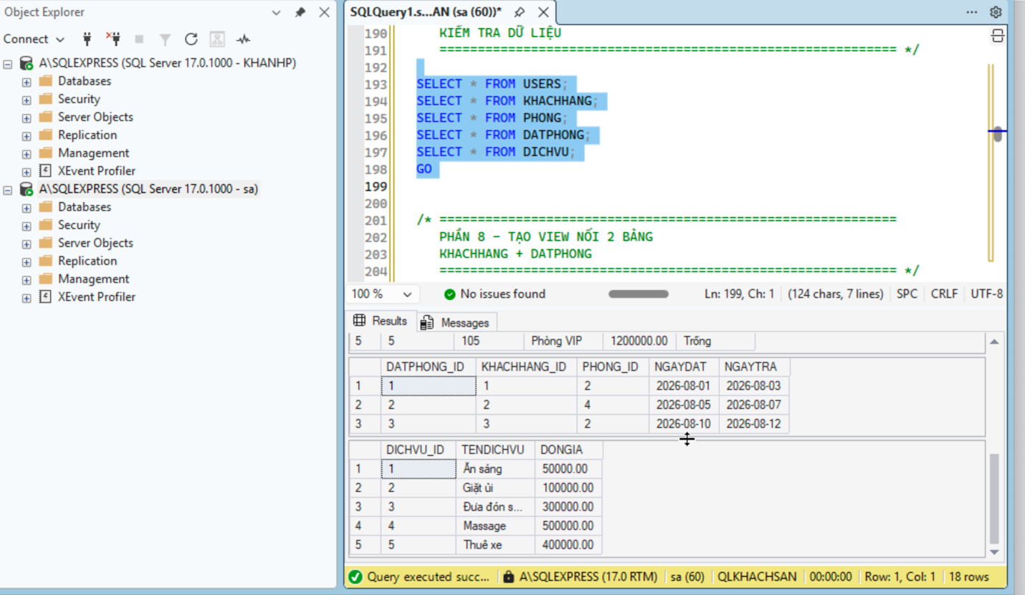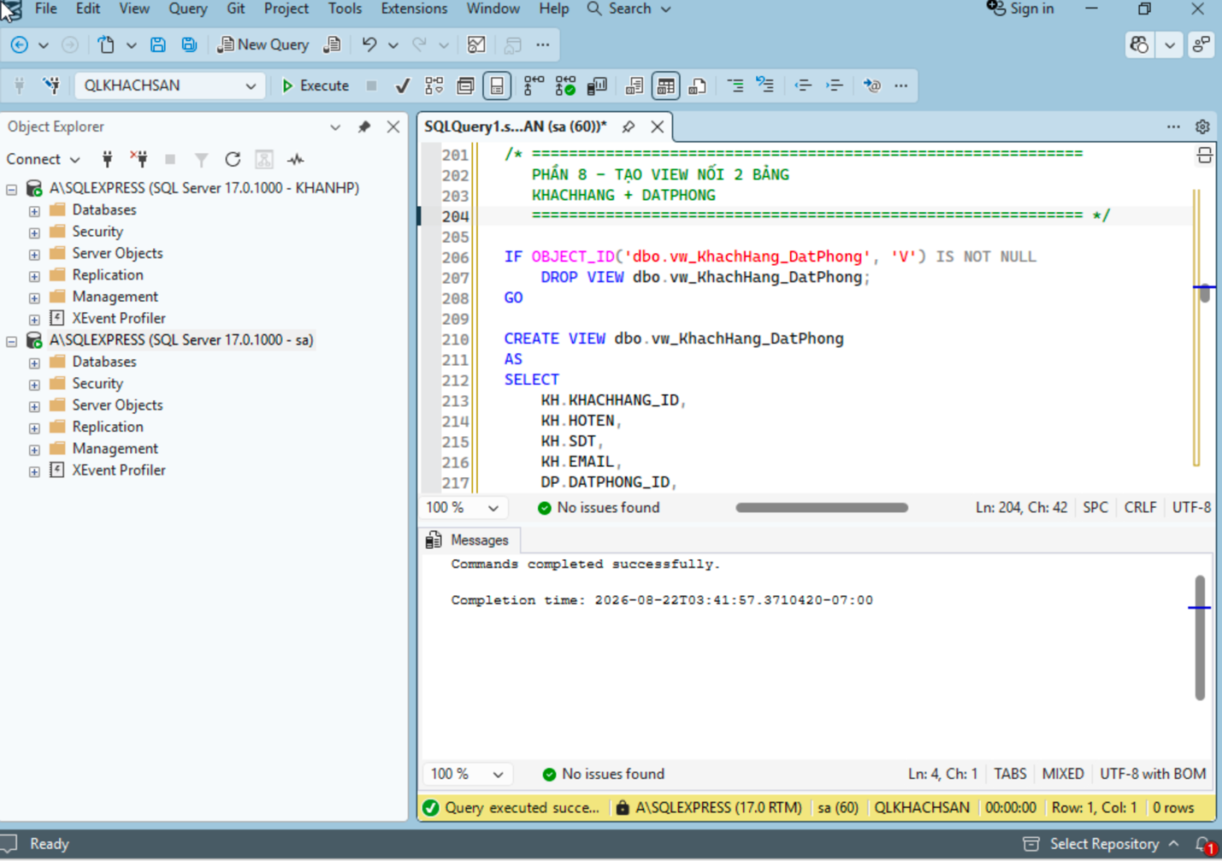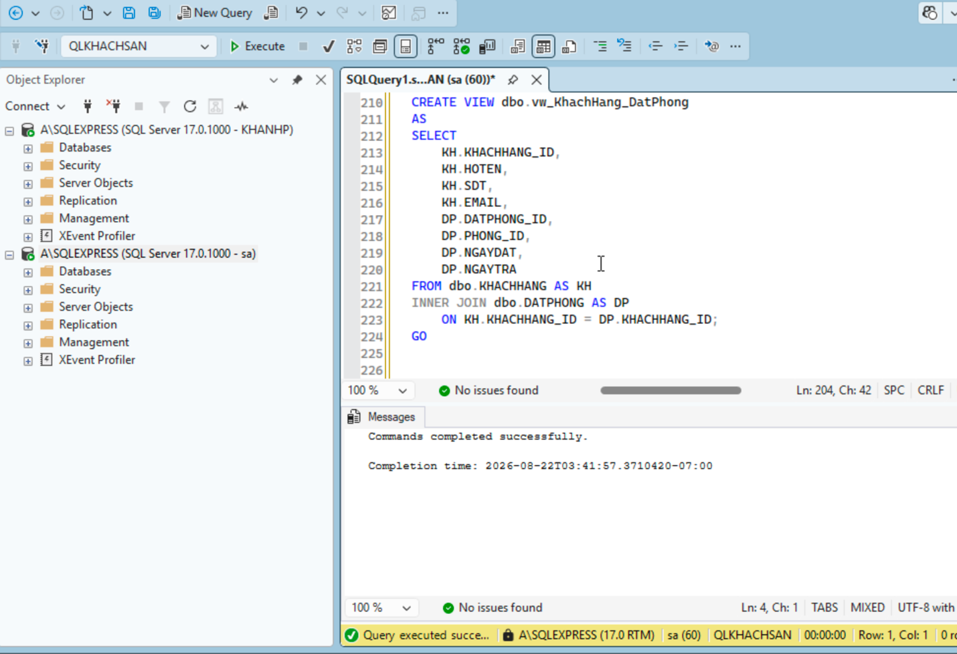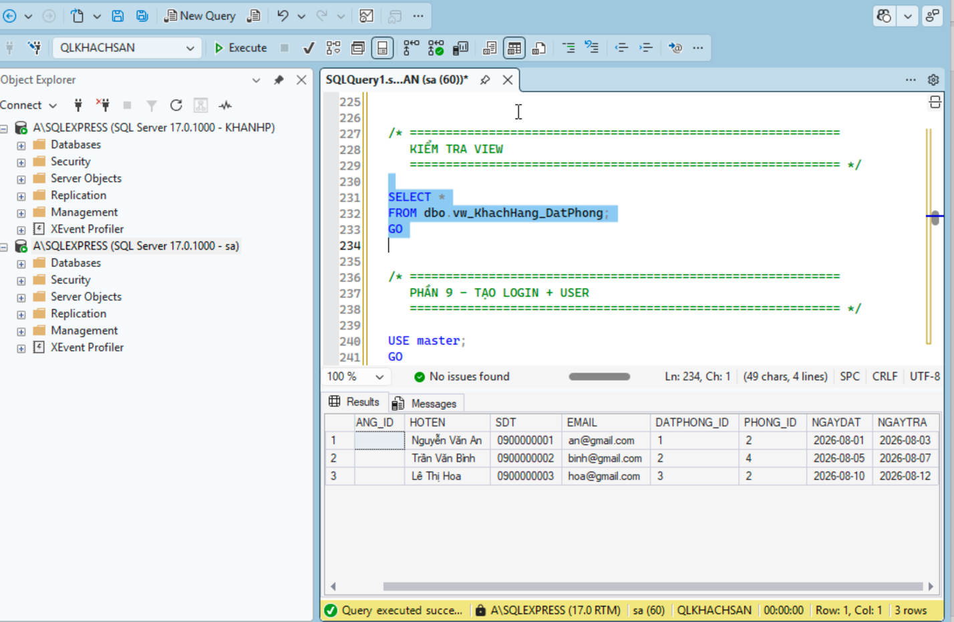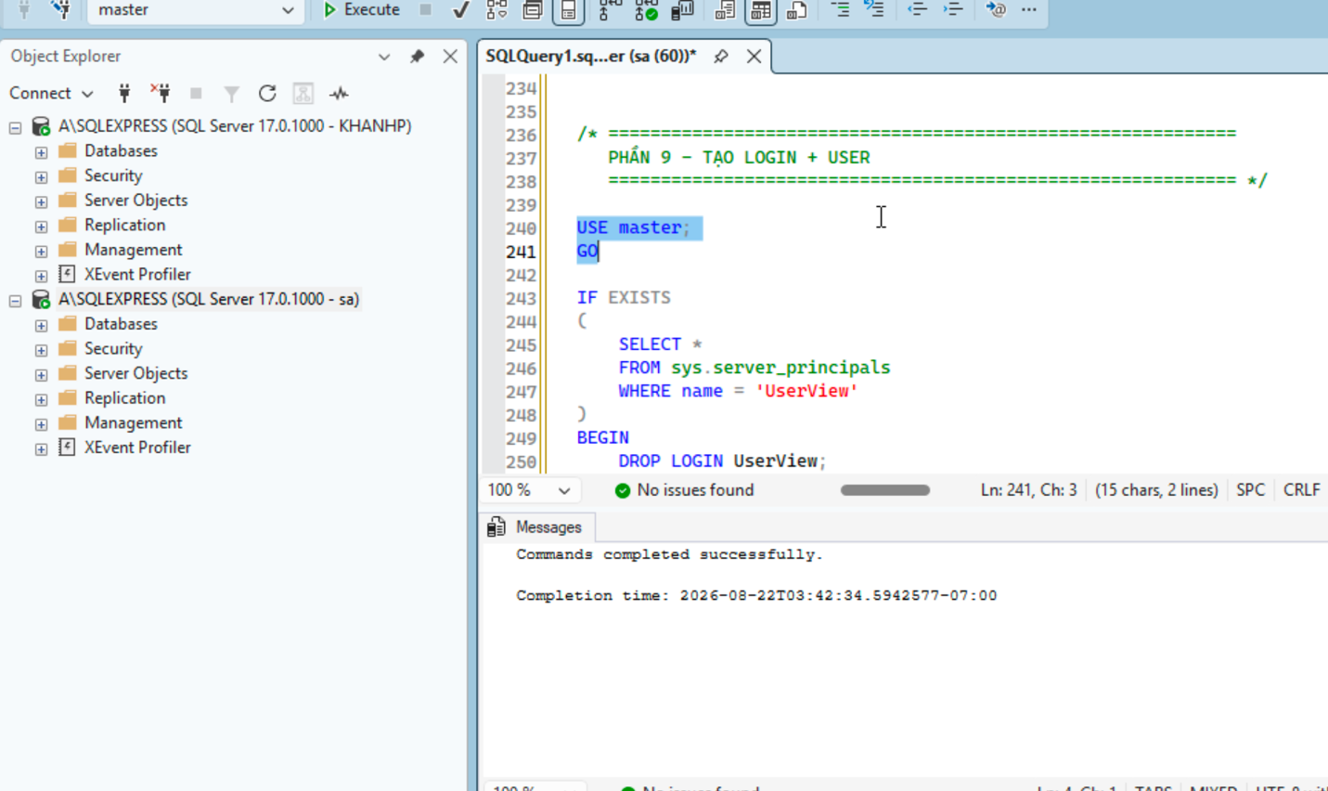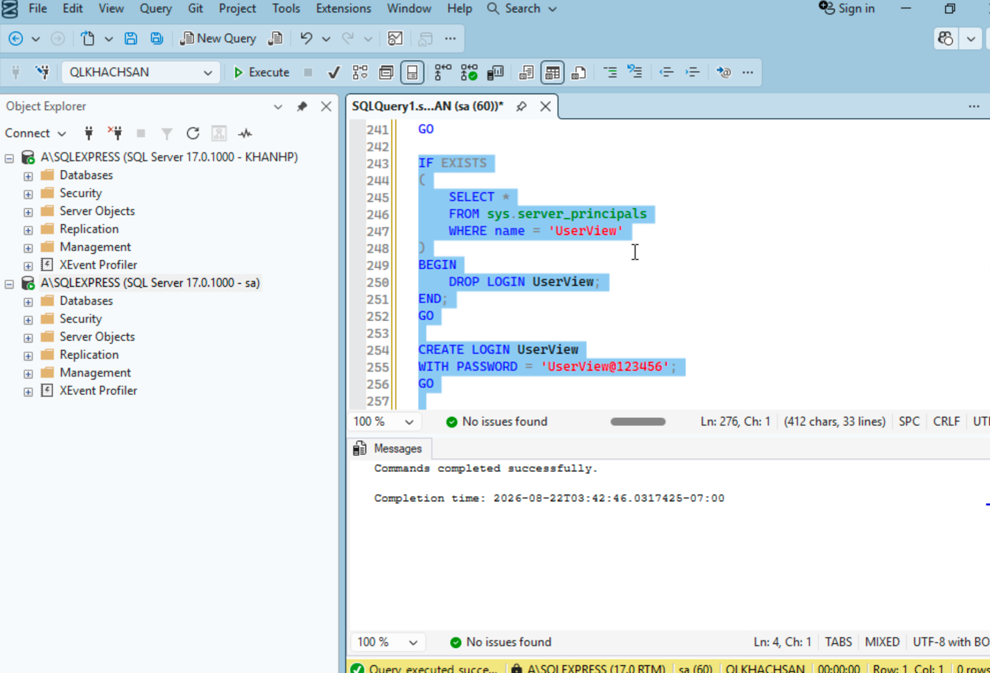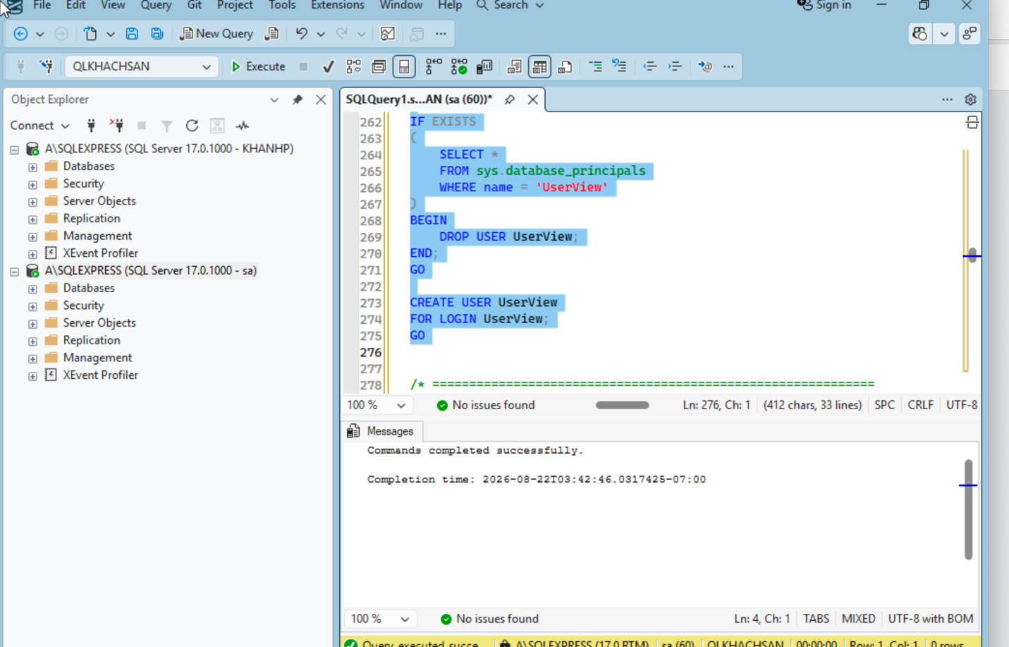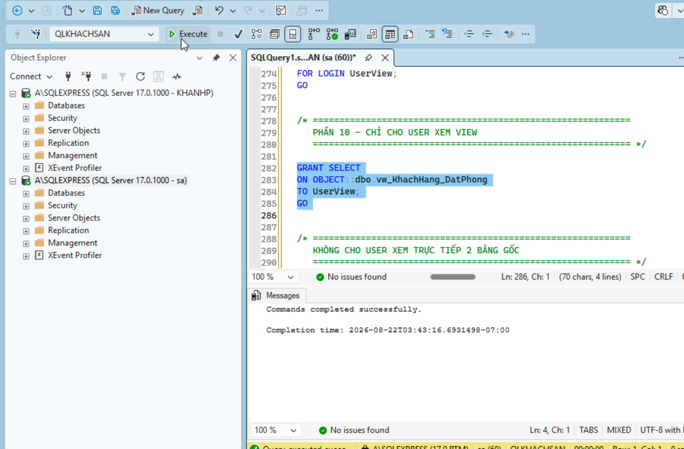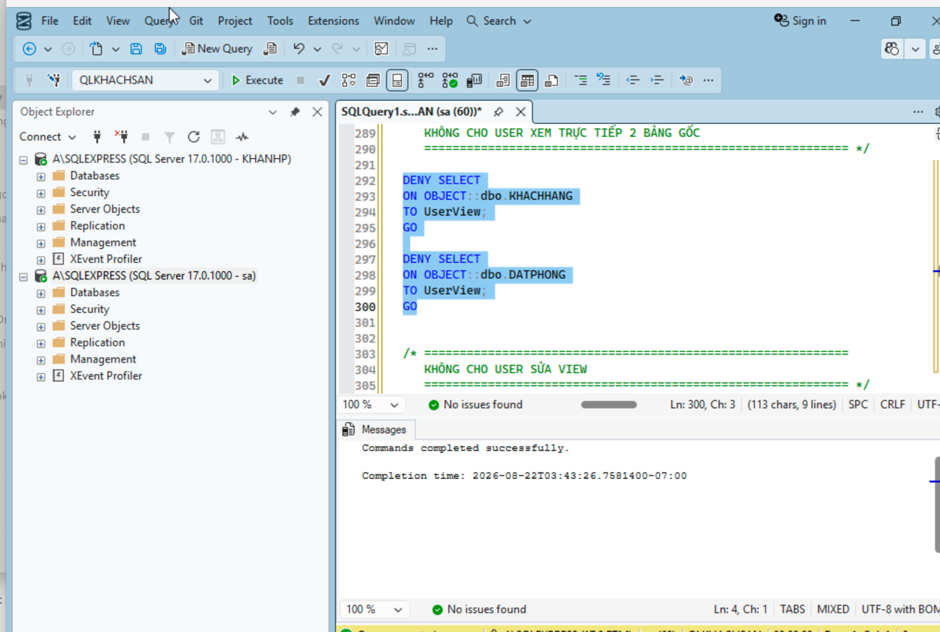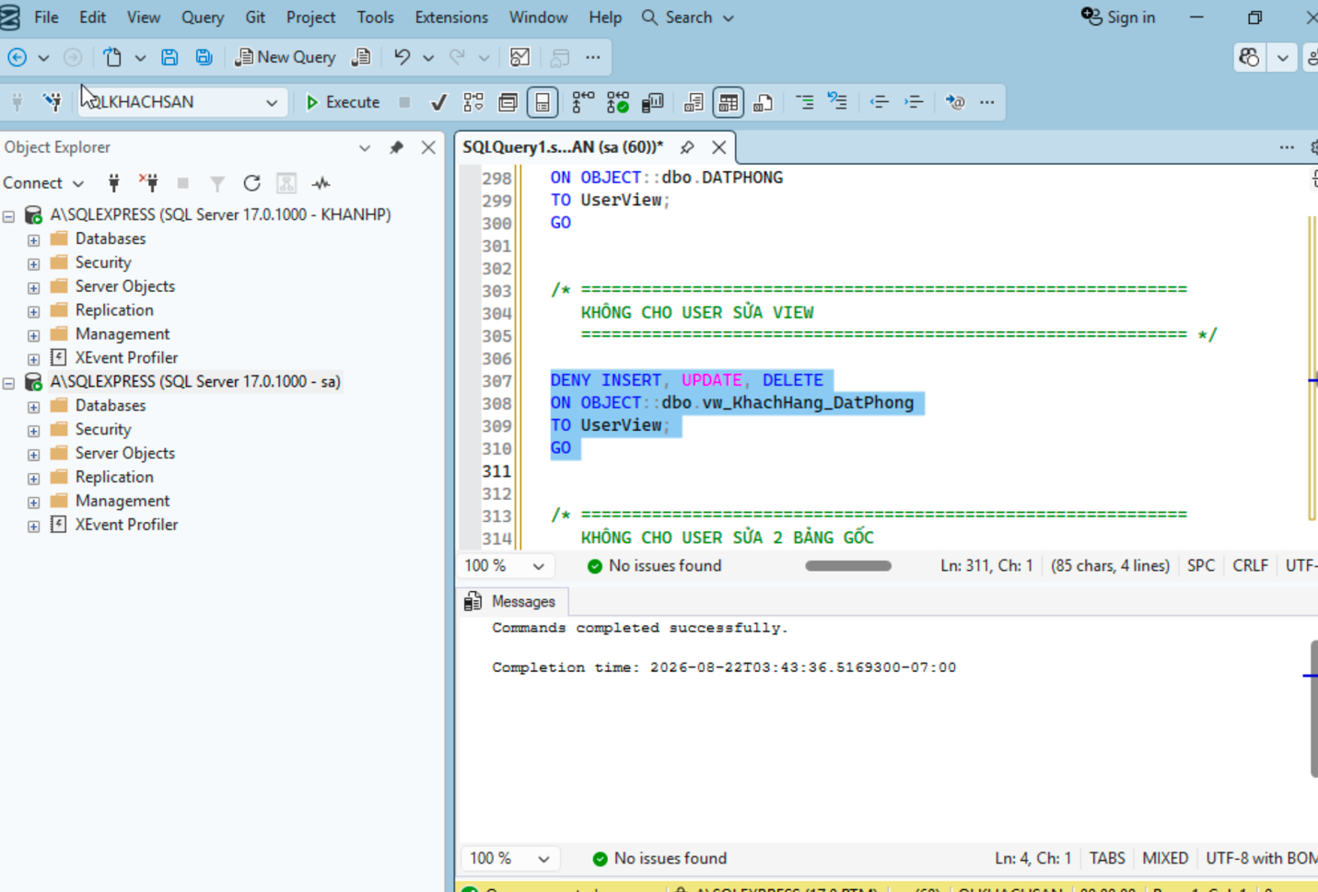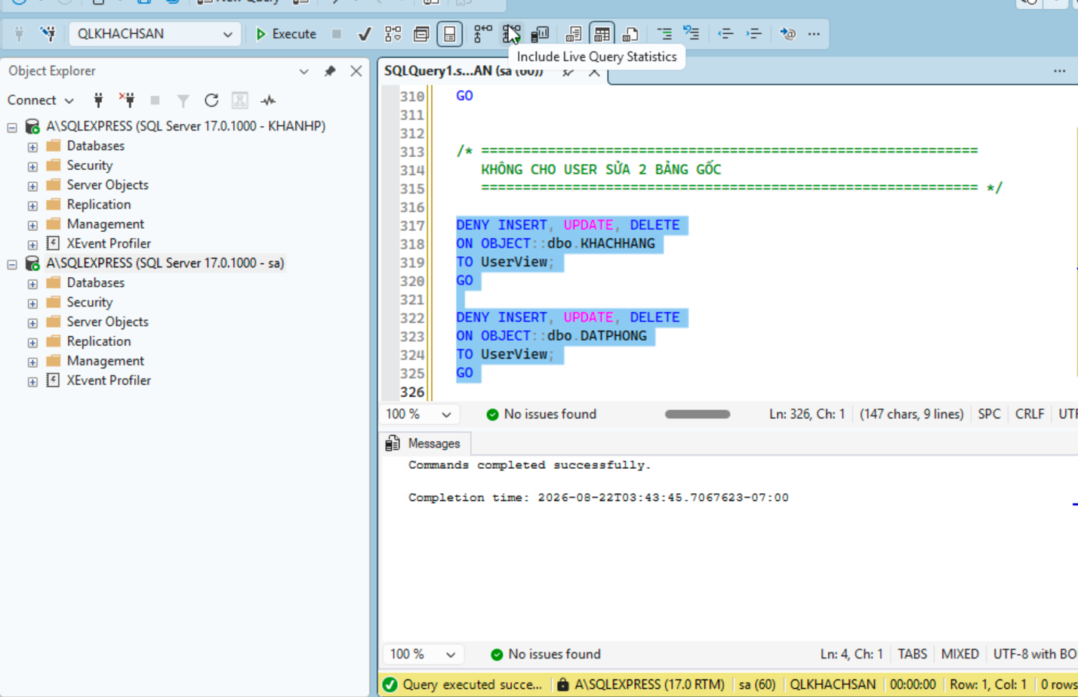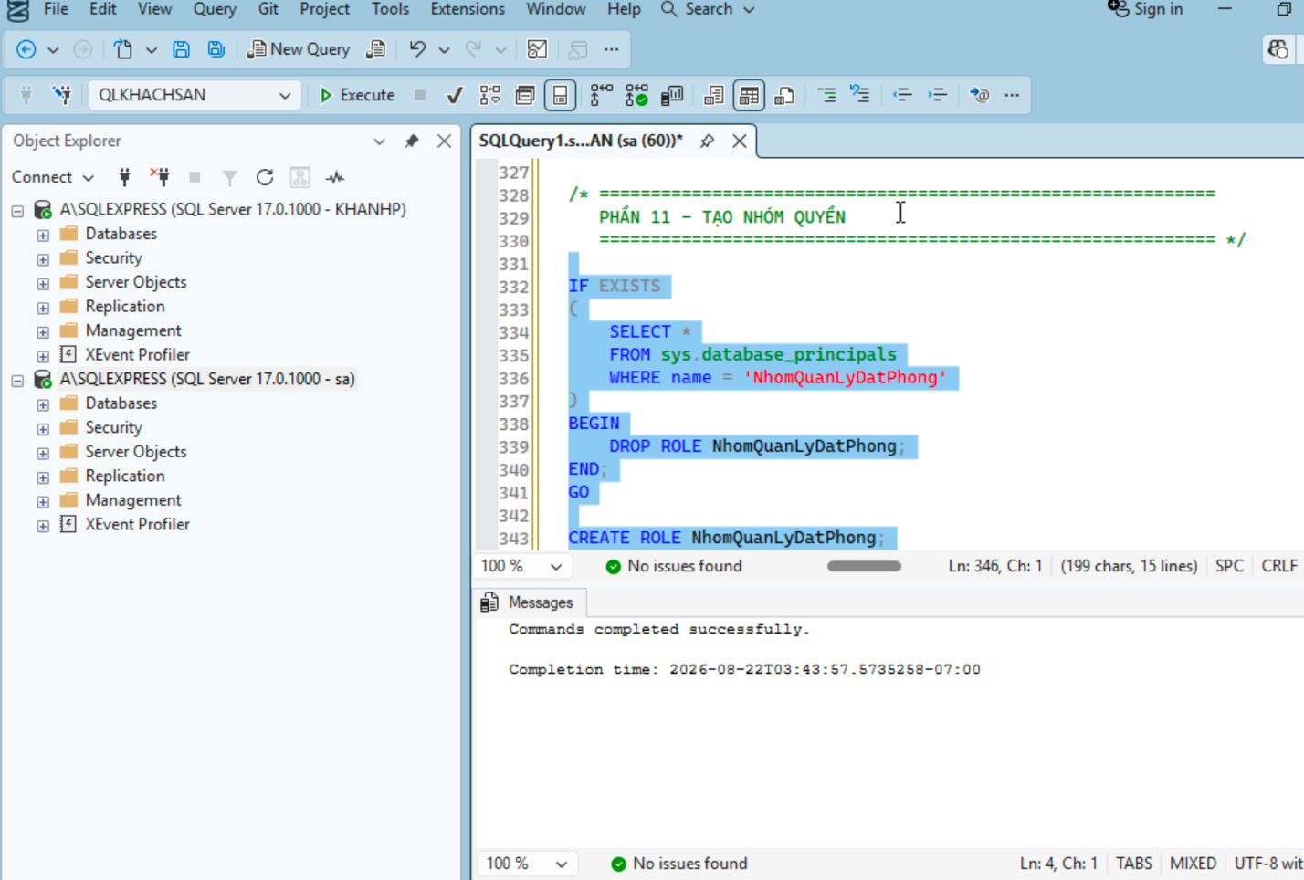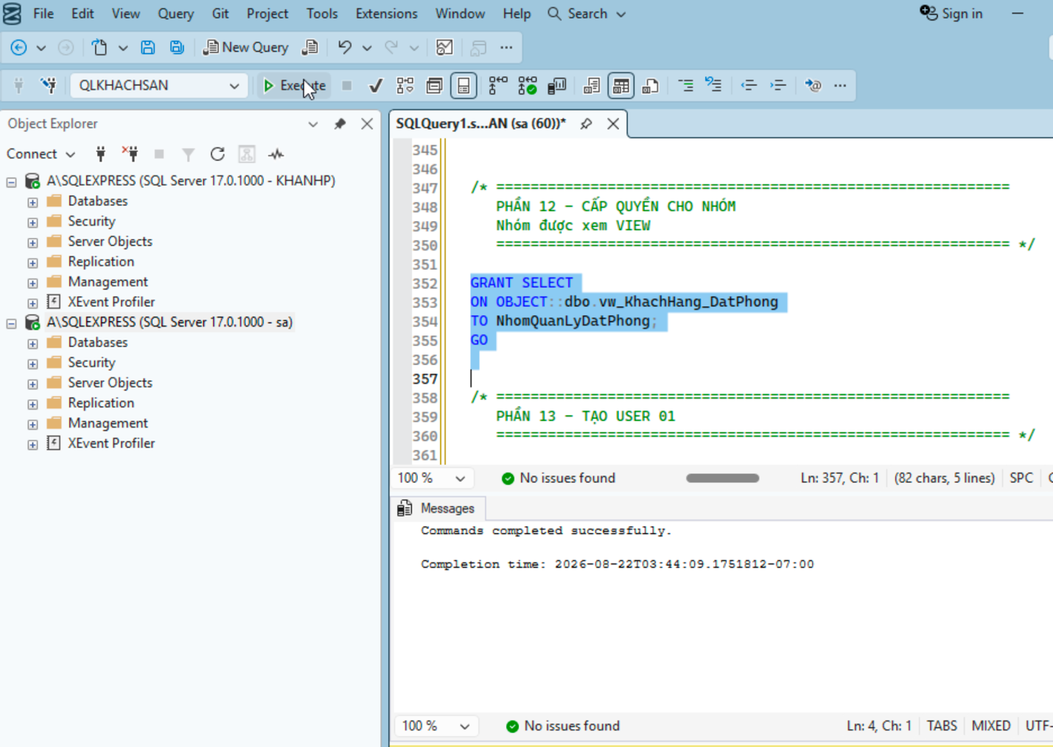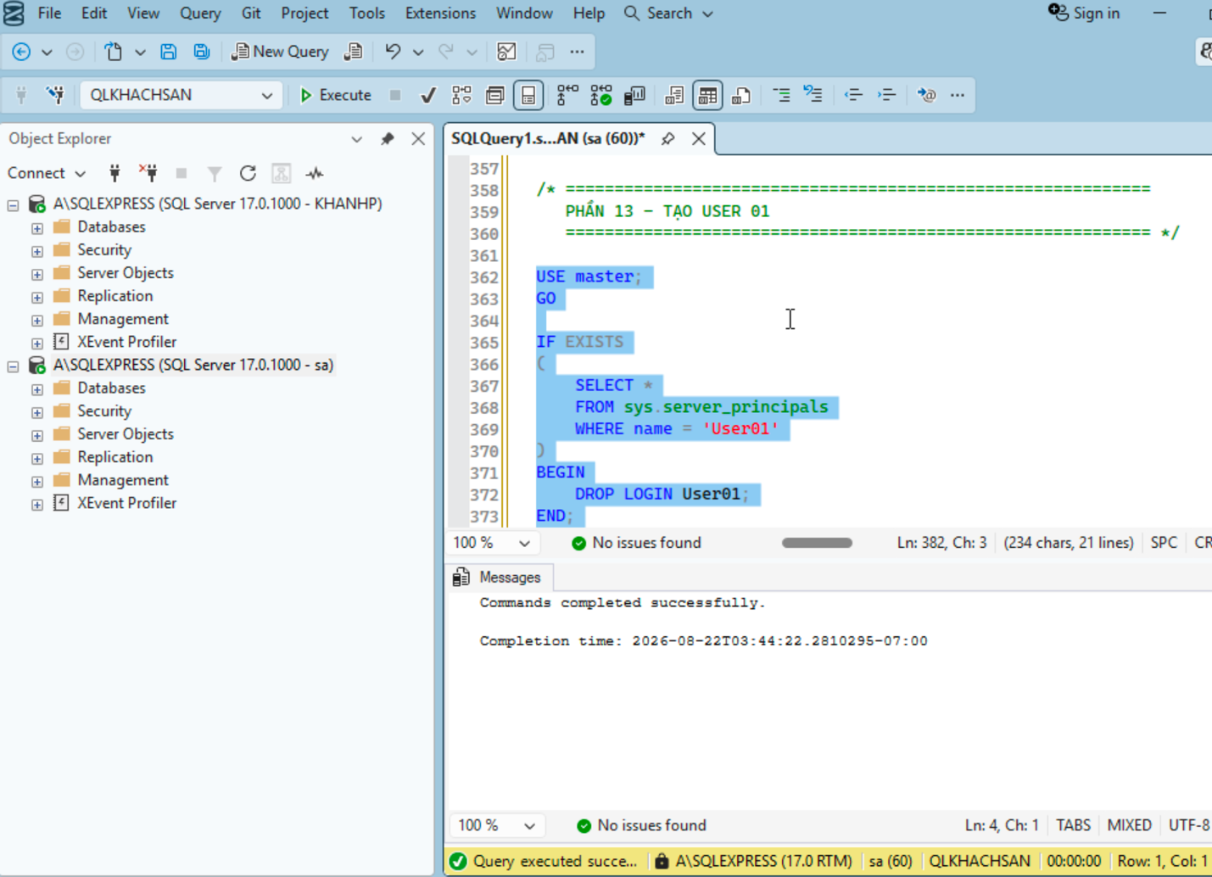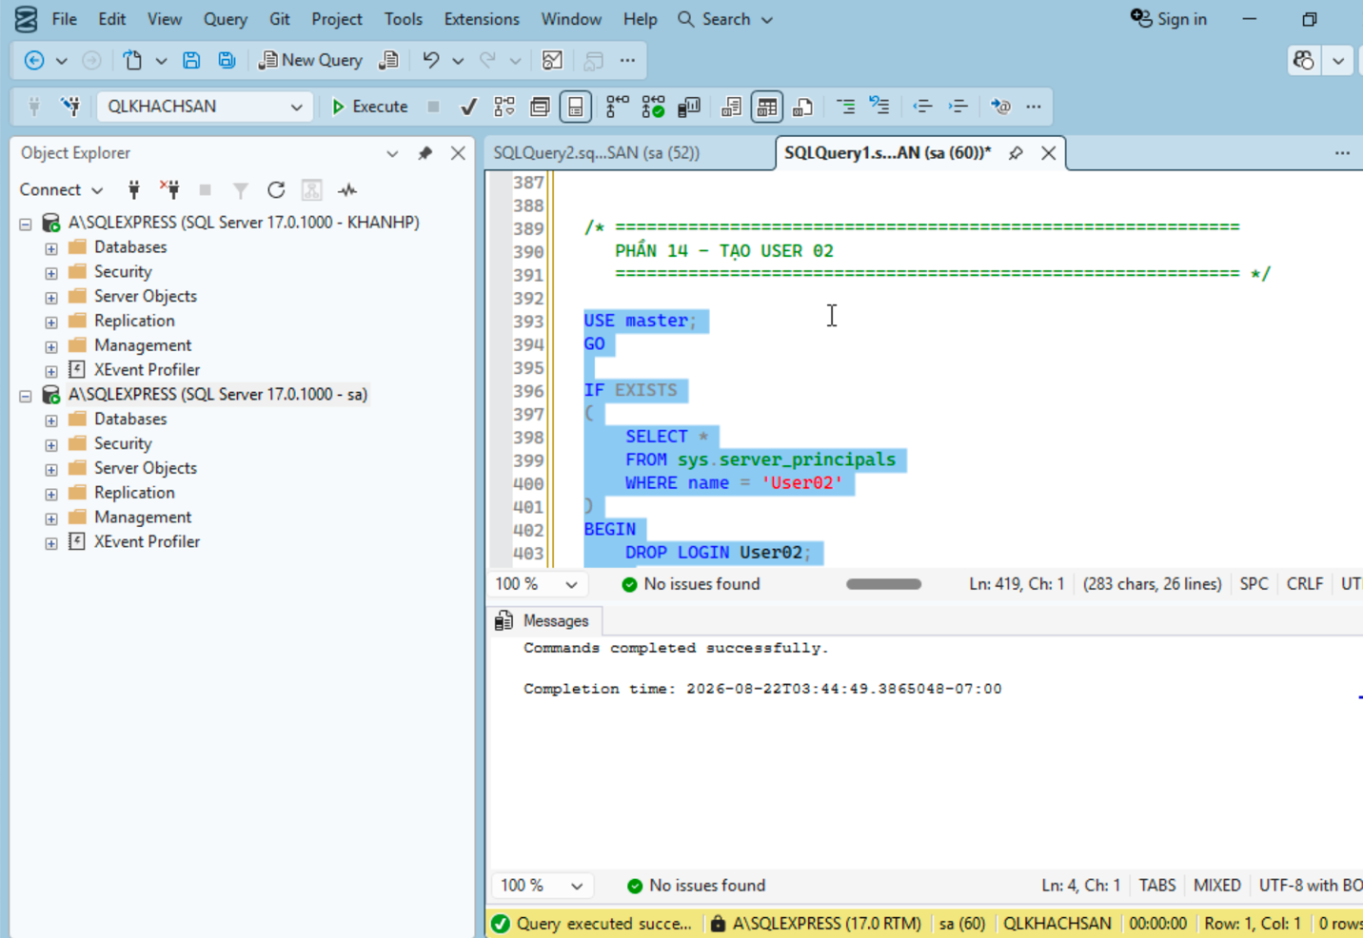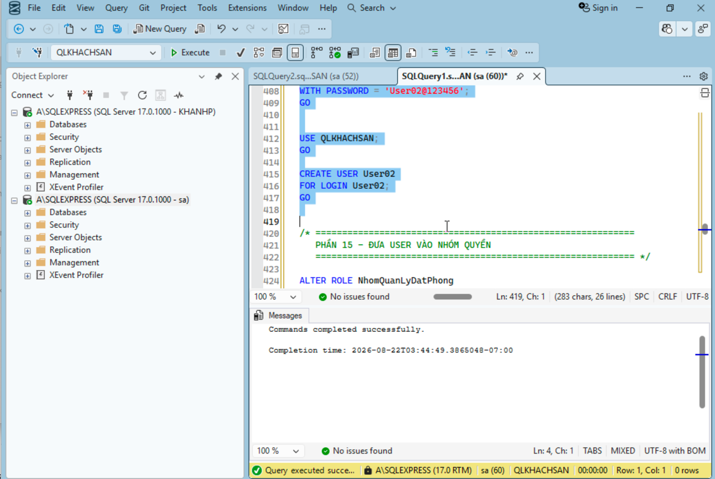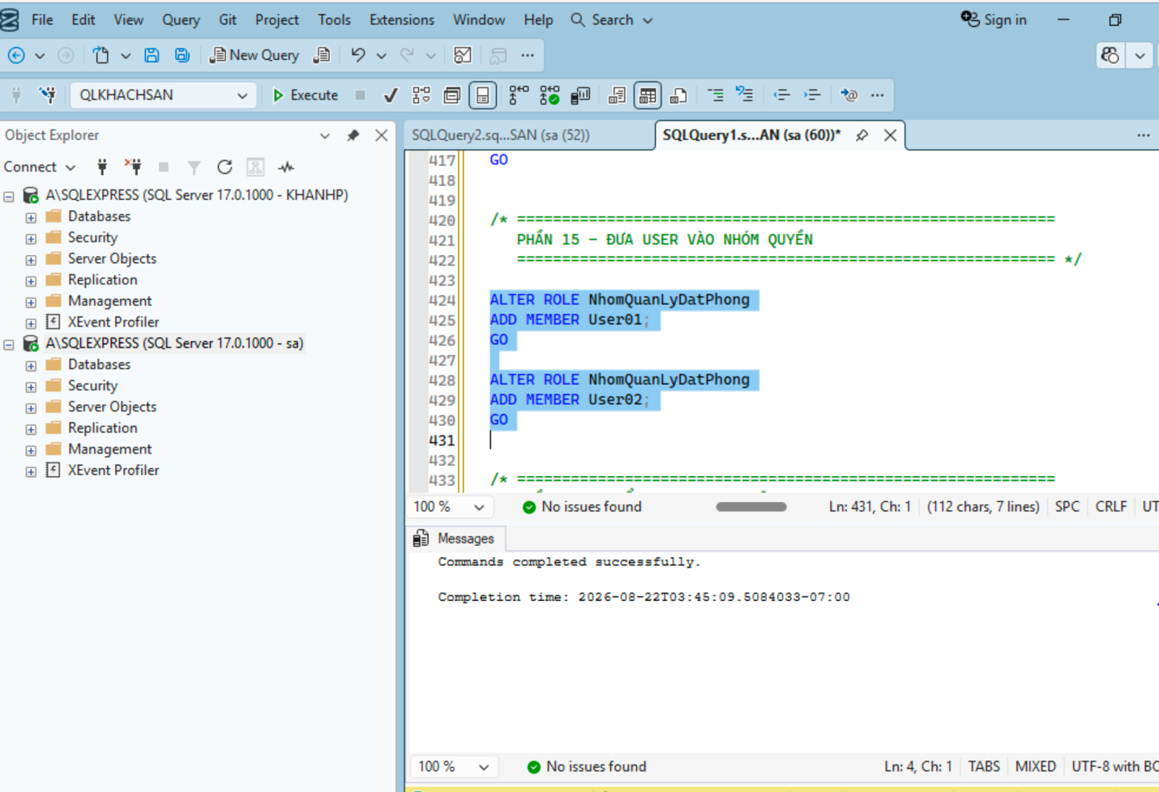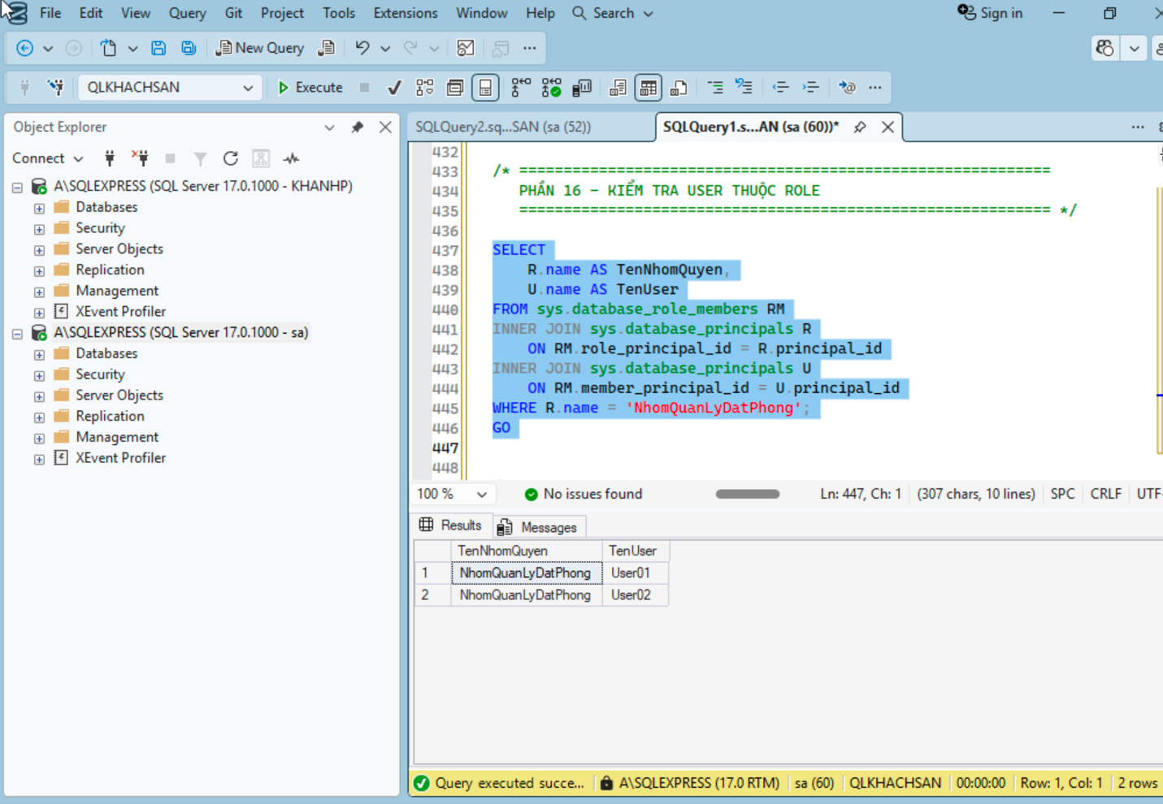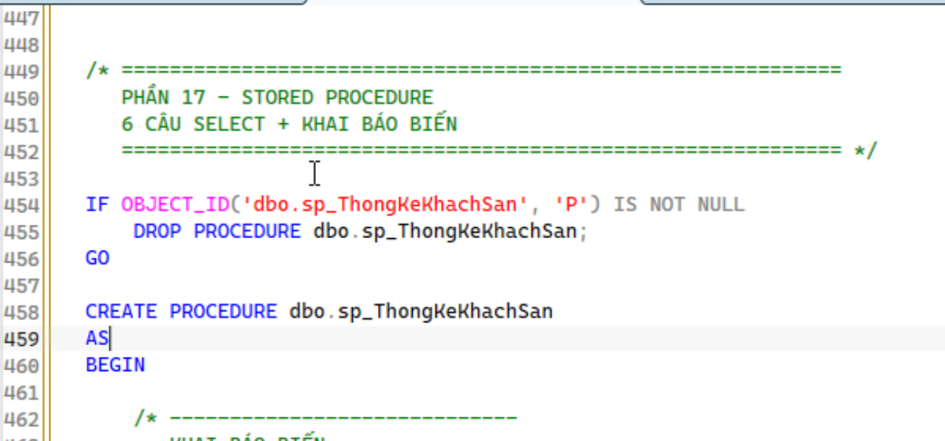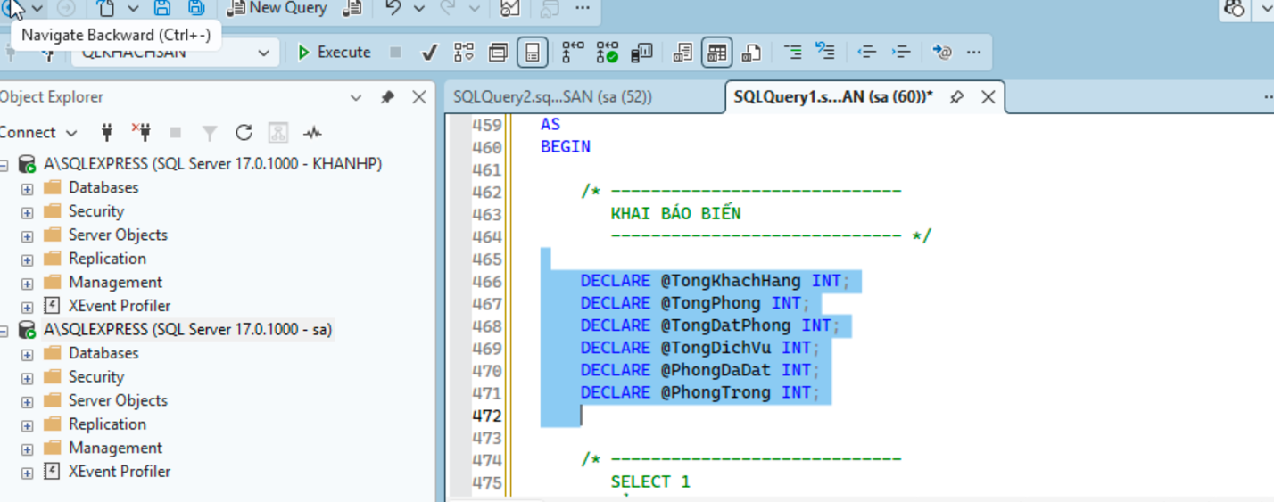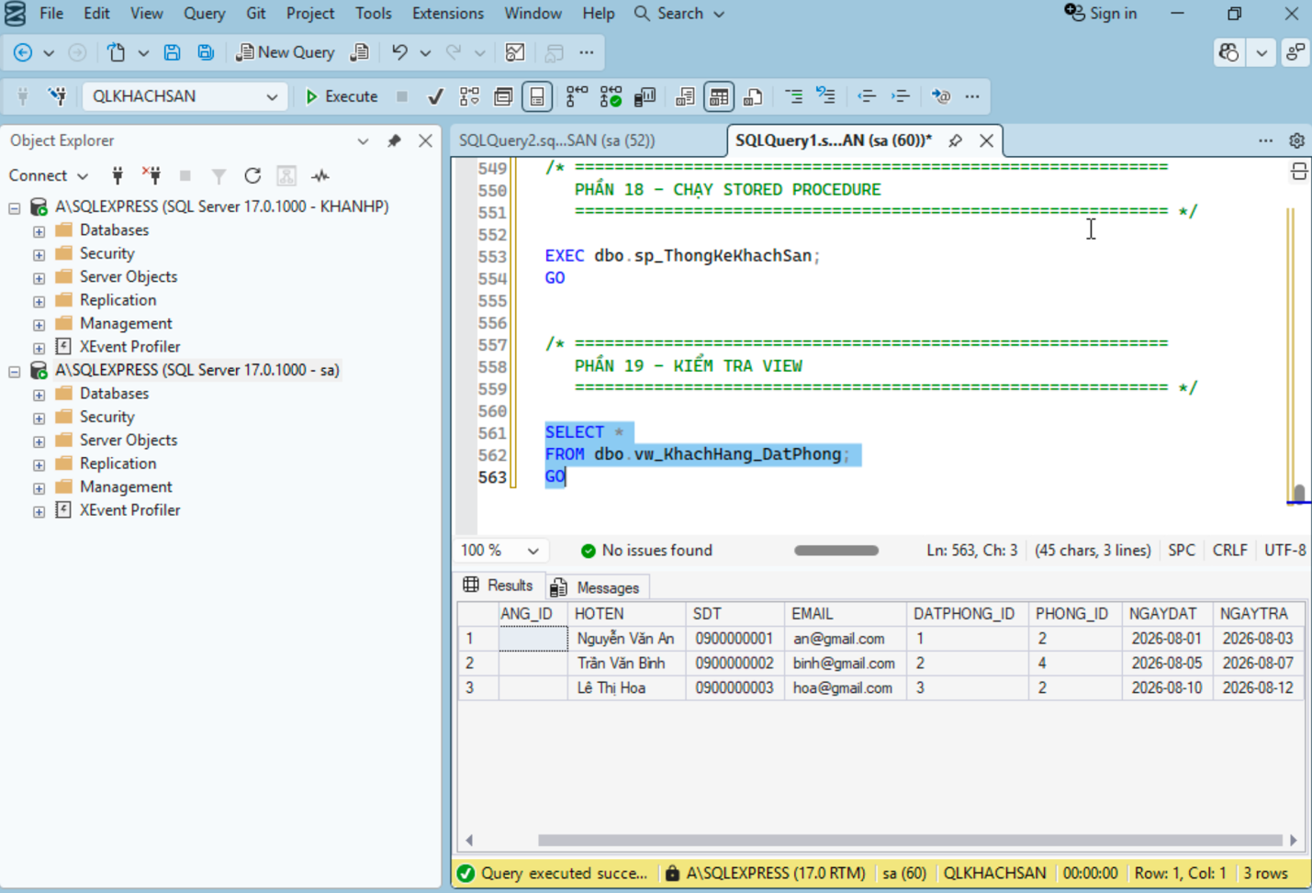

BÀI THỰC HÀNH:
1. Lưu mật khẩu đã hash từ C#
2. VIEW JOIN 2 bảng
3. USER + phân quyền
4. ROLE + thêm USER vào ROLE
5. STORED PROCEDURE gồm 6 SELECT + biến

/*
=====================================================
PHẦN 1 - TẠO DATABASE
============================================================ */

USE master;
GO

IF DB_ID('QLKHACHSAN') IS NULL
BEGIN
CREATE DATABASE QLKHACHSAN;
END;
GO

USE QLKHACHSAN;
GO

/* ============================================================
PHẦN 2 - TẠO BẢNG USERS
Dùng để C# lưu mật khẩu đã hash
============================================================ */

IF OBJECT_ID('dbo.USERS', 'U') IS NOT NULL
DROP TABLE dbo.USERS;
GO

CREATE TABLE USERS
(
UserID INT IDENTITY(1,1) PRIMARY KEY,
Username NVARCHAR(50) NOT NULL UNIQUE,
PasswordHash VARCHAR(64) NOT NULL
);
GO

/* ============================================================
PHẦN 3 - TẠO BẢNG KHACHHANG
============================================================ */

IF OBJECT_ID('dbo.KHACHHANG', 'U') IS NOT NULL
DROP TABLE dbo.KHACHHANG;
GO

CREATE TABLE KHACHHANG
(
KHACHHANG_ID INT IDENTITY(1,1) PRIMARY KEY,
HOTEN NVARCHAR(100) NOT NULL,
SDT VARCHAR(15),
EMAIL VARCHAR(100)
);
GO

/* ============================================================
PHẦN 4 - TẠO BẢNG PHONG
============================================================ */

IF OBJECT_ID('dbo.PHONG', 'U') IS NOT NULL
DROP TABLE dbo.PHONG;
GO

CREATE TABLE PHONG
(
PHONG_ID INT IDENTITY(1,1) PRIMARY KEY,
SOPHONG VARCHAR(10) NOT NULL,
LOAIPHONG NVARCHAR(50),
GIAPHONG DECIMAL(18,2),
TRANGTHAI NVARCHAR(30)
);
GO

/* ============================================================
PHẦN 5 - TẠO BẢNG DATPHONG
============================================================ */

IF OBJECT_ID('dbo.DATPHONG', 'U') IS NOT NULL
DROP TABLE dbo.DATPHONG;
GO

CREATE TABLE DATPHONG
(
DATPHONG_ID INT IDENTITY(1,1) PRIMARY KEY,
KHACHHANG_ID INT NOT NULL,
PHONG_ID INT NOT NULL,
NGAYDAT DATE NOT NULL,
NGAYTRA DATE NOT NULL,

CONSTRAINT FK_DATPHONG_KHACHHANG
FOREIGN KEY (KHACHHANG_ID)
REFERENCES KHACHHANG(KHACHHANG_ID),

CONSTRAINT FK_DATPHONG_PHONG
FOREIGN KEY (PHONG_ID)
REFERENCES PHONG(PHONG_ID)
);
GO

/* ============================================================
PHẦN 6 - TẠO BẢNG DICHVU
============================================================ */

IF OBJECT_ID('dbo.DICHVU', 'U') IS NOT NULL
DROP TABLE dbo.DICHVU;
GO

CREATE TABLE DICHVU
(
DICHVU_ID INT IDENTITY(1,1) PRIMARY KEY,
TENDICHVU NVARCHAR(100) NOT NULL,
DONGIA DECIMAL(18,2)
);
GO

/* ============================================================
PHẦN 7 - THÊM DỮ LIỆU MẪU
============================================================ */

INSERT INTO KHACHHANG
(
HOTEN,
SDT,
EMAIL
)
VALUES
(N'Nguyễn Văn An', '0900000001', 'an@gmail.com'),
(N'Trần Văn Bình', '0900000002', 'binh@gmail.com'),
(N'Lê Thị Hoa', '0900000003', 'hoa@gmail.com'),
(N'Phạm Văn Nam', '0900000004', 'nam@gmail.com'),
(N'Hoàng Thị Lan', '0900000005', 'lan@gmail.com');
GO

INSERT INTO PHONG
(
SOPHONG,
LOAIPHONG,
GIAPHONG,
TRANGTHAI
)
VALUES
('101', N'Phòng đơn', 300000, N'Trống'),
('102', N'Phòng đôi', 500000, N'Đã đặt'),
('103', N'Phòng VIP', 1000000, N'Trống'),
('104', N'Phòng đôi', 500000, N'Đã đặt'),
('105', N'Phòng VIP', 1200000, N'Trống');
GO

INSERT INTO DATPHONG
(
KHACHHANG_ID,
PHONG_ID,
NGAYDAT,
NGAYTRA
)
VALUES
(1, 2, '2026-08-01', '2026-08-03'),
(2, 4, '2026-08-05', '2026-08-07'),
(3, 2, '2026-08-10', '2026-08-12');
GO

INSERT INTO DICHVU
(
TENDICHVU,
DONGIA
)
VALUES
(N'Ăn sáng', 50000),
(N'Giặt ủi', 100000),
(N'Đưa đón sân bay', 300000),
(N'Massage', 500000),
(N'Thuê xe', 400000);
GO

/* ============================================================
KIỂM TRA DỮ LIỆU
============================================================ */

SELECT * FROM USERS;
SELECT * FROM KHACHHANG;
SELECT * FROM PHONG;
SELECT * FROM DATPHONG;
SELECT * FROM DICHVU;
GO

/* ============================================================
PHẦN 8 - TẠO VIEW NỐI 2 BẢNG
KHACHHANG + DATPHONG
============================================================ */

IF OBJECT_ID('dbo.vw_KhachHang_DatPhong', 'V') IS NOT NULL
DROP VIEW dbo.vw_KhachHang_DatPhong;
GO

CREATE VIEW dbo.vw_KhachHang_DatPhong
AS
SELECT
KH.KHACHHANG_ID,
KH.HOTEN,
KH.SDT,
KH.EMAIL,
DP.DATPHONG_ID,
DP.PHONG_ID,
DP.NGAYDAT,
DP.NGAYTRA
FROM dbo.KHACHHANG AS KH
INNER JOIN dbo.DATPHONG AS DP
ON KH.KHACHHANG_ID = DP.KHACHHANG_ID;
GO

/* ============================================================
KIỂM TRA VIEW
============================================================ */

SELECT *
FROM dbo.vw_KhachHang_DatPhong;
GO

/* ============================================================
PHẦN 9 - TẠO LOGIN + USER
============================================================ */

USE master;
GO

IF EXISTS
(
SELECT *
FROM sys.server_principals
WHERE name = 'UserView'
)
BEGIN
DROP LOGIN UserView;
END;
GO

CREATE LOGIN UserView
WITH PASSWORD = 'UserView@123456';
GO

USE QLKHACHSAN;
GO

IF EXISTS
(
SELECT *
FROM sys.database_principals
WHERE name = 'UserView'
)
BEGIN
DROP USER UserView;
END;
GO

CREATE USER UserView
FOR LOGIN UserView;
GO

/* ============================================================
PHẦN 10 - CHỈ CHO USER XEM VIEW
============================================================ */

GRANT SELECT
ON OBJECT::dbo.vw_KhachHang_DatPhong
TO UserView;
GO

/* ============================================================
KHÔNG CHO USER XEM TRỰC TIẾP 2 BẢNG GỐC
============================================================ */

DENY SELECT
ON OBJECT::dbo.KHACHHANG
TO UserView;
GO

DENY SELECT
ON OBJECT::dbo.DATPHONG
TO UserView;
GO

/* ============================================================
KHÔNG CHO USER SỬA VIEW
============================================================ */

DENY INSERT, UPDATE, DELETE
ON OBJECT::dbo.vw_KhachHang_DatPhong
TO UserView;
GO

/* ============================================================
KHÔNG CHO USER SỬA 2 BẢNG GỐC
============================================================ */

DENY INSERT, UPDATE, DELETE
ON OBJECT::dbo.KHACHHANG
TO UserView;
GO

DENY INSERT, UPDATE, DELETE
ON OBJECT::dbo.DATPHONG
TO UserView;
GO

/* ============================================================
PHẦN 11 - TẠO NHÓM QUYỀN
============================================================ */

IF EXISTS
(
SELECT *
FROM sys.database_principals
WHERE name = 'NhomQuanLyDatPhong'
)
BEGIN
DROP ROLE NhomQuanLyDatPhong;
END;
GO

CREATE ROLE NhomQuanLyDatPhong;
GO

/* ============================================================
PHẦN 12 - CẤP QUYỀN CHO NHÓM
Nhóm được xem VIEW
============================================================ */

GRANT SELECT
ON OBJECT::dbo.vw_KhachHang_DatPhong
TO NhomQuanLyDatPhong;
GO

/* ============================================================
PHẦN 13 - TẠO USER 01
============================================================ */

USE master;
GO

IF EXISTS
(
SELECT *
FROM sys.server_principals
WHERE name = 'User01'
)
BEGIN
DROP LOGIN User01;
END;
GO

CREATE LOGIN User01
WITH PASSWORD = 'User01@123456';
GO

USE QLKHACHSAN;
GO

CREATE USER User01
FOR LOGIN User01;
GO

/* ============================================================
PHẦN 14 - TẠO USER 02
============================================================ */

USE master;
GO

IF EXISTS
(
SELECT *
FROM sys.server_principals
WHERE name = 'User02'
)
BEGIN
DROP LOGIN User02;
END;
GO

CREATE LOGIN User02
WITH PASSWORD = 'User02@123456';
GO

USE QLKHACHSAN;
GO

CREATE USER User02
FOR LOGIN User02;
GO

/* ============================================================
PHẦN 15 - ĐƯA USER VÀO NHÓM QUYỀN
============================================================ */

ALTER ROLE NhomQuanLyDatPhong
ADD MEMBER User01;
GO

ALTER ROLE NhomQuanLyDatPhong
ADD MEMBER User02;
GO

/* ============================================================
PHẦN 16 - KIỂM TRA USER THUỘC ROLE
============================================================ */

SELECT
R.name AS TenNhomQuyen,
U.name AS TenUser
FROM sys.database_role_members RM
INNER JOIN sys.database_principals R
ON RM.role_principal_id = R.principal_id
INNER JOIN sys.database_principals U
ON RM.member_principal_id = U.principal_id
WHERE R.name = 'NhomQuanLyDatPhong';
GO

/* ============================================================
PHẦN 17 - STORED PROCEDURE
6 CÂU SELECT + KHAI BÁO BIẾN
============================================================ */

IF OBJECT_ID('dbo.sp_ThongKeKhachSan', 'P') IS NOT NULL
DROP PROCEDURE dbo.sp_ThongKeKhachSan;
GO

CREATE PROCEDURE dbo.sp_ThongKeKhachSan
AS
BEGIN

/* -----------------------------
KHAI BÁO BIẾN
----------------------------- */

DECLARE @TongKhachHang INT;
DECLARE @TongPhong INT;
DECLARE @TongDatPhong INT;
DECLARE @TongDichVu INT;
DECLARE @PhongDaDat INT;
DECLARE @PhongTrong INT;

/* -----------------------------
SELECT 1
BẢNG 1: KHACHHANG
----------------------------- */

SELECT
@TongKhachHang = COUNT(*)
FROM KHACHHANG;

/* -----------------------------
SELECT 2
BẢNG 2: PHONG
----------------------------- */

SELECT
@TongPhong = COUNT(*)
FROM PHONG;

/* -----------------------------
SELECT 3
BẢNG 3: DATPHONG
----------------------------- */

SELECT
@TongDatPhong = COUNT(*)
FROM DATPHONG;

/* -----------------------------
SELECT 4
BẢNG 4: DICHVU
----------------------------- */

SELECT
@TongDichVu = COUNT(*)
FROM DICHVU;

/* -----------------------------
SELECT 5
BẢNG DATPHONG
----------------------------- */

SELECT
@PhongDaDat = COUNT(DISTINCT PHONG_ID)
FROM DATPHONG;

/* -----------------------------
SELECT 6
TÍNH PHÒNG TRỐNG
----------------------------- */

SELECT
@PhongTrong = @TongPhong - @PhongDaDat;

/* -----------------------------
HIỂN THỊ KẾT QUẢ
----------------------------- */

SELECT
@TongKhachHang AS TongKhachHang,
@TongPhong AS TongPhong,
@TongDatPhong AS TongDatPhong,
@TongDichVu AS TongDichVu,
@PhongDaDat AS PhongDaDat,
@PhongTrong AS PhongTrong;

END;
GO

/* ============================================================
PHẦN 18 - CHẠY STORED PROCEDURE
============================================================ */

EXEC dbo.sp_ThongKeKhachSan;
GO

/* ============================================================
PHẦN 19 - KIỂM TRA VIEW
============================================================ */

SELECT *
FROM dbo.vw_KhachHang_DatPhong;
GO
